# Netstat Commands

Agasthya P – CH.EN.U4CYS22004

**1.** **netstat**

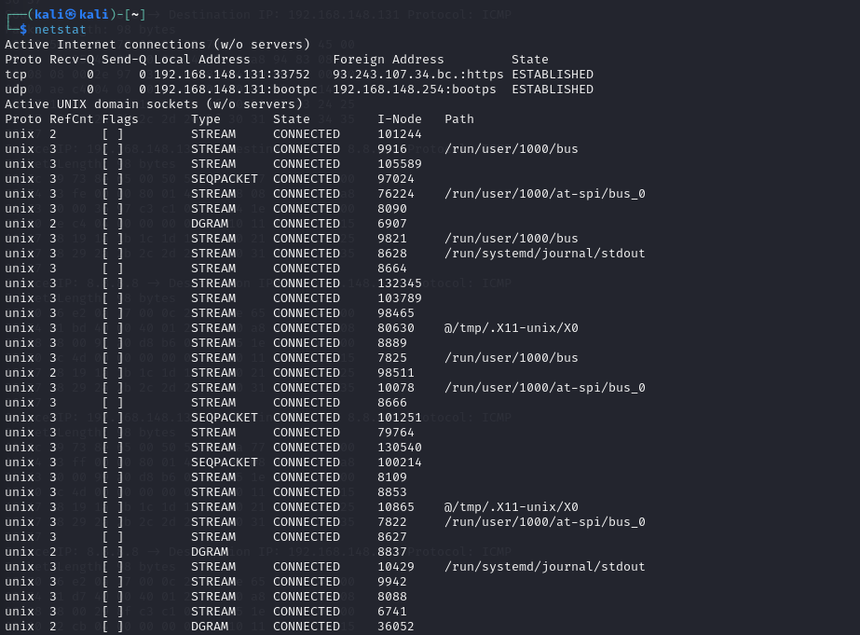

**2.List All Ports and Connections**

To list all ports and connections regardless of their state or protocol, use:

netstat -a

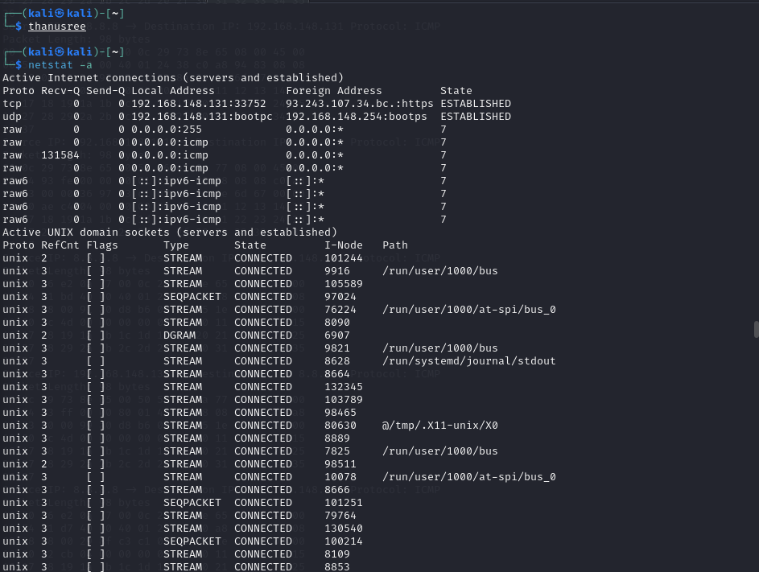

**3.List All TCP Ports**

List all TCP ports by running:

netstat -at

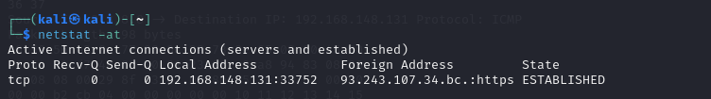

**4.List All UDP Ports**

List all UDP ports with:

netstat -au

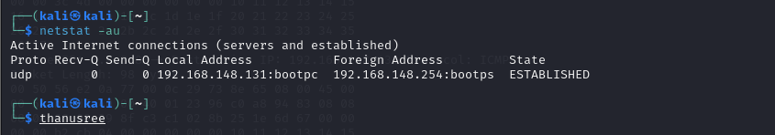

### **5.List Only Listening Ports**

To return a list of only listening ports for all protocols, use:

netstat -l

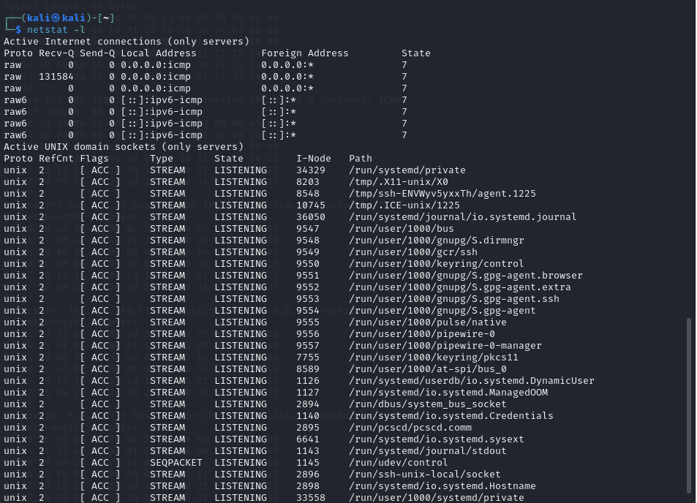

****6.List TCP Listening Ports****

List all listening TCP ports with:

netstat -lt

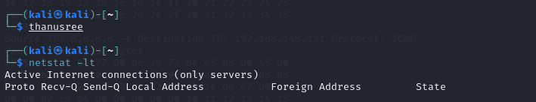

****7.List UDP Listening Ports****

Return only listening UDP ports by running:

netstat -lu

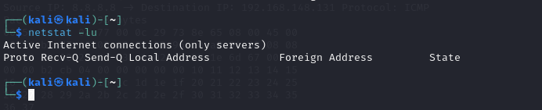

8.List UNIX Listening Ports

To list UNIX listening ports, use:

netstat -lx

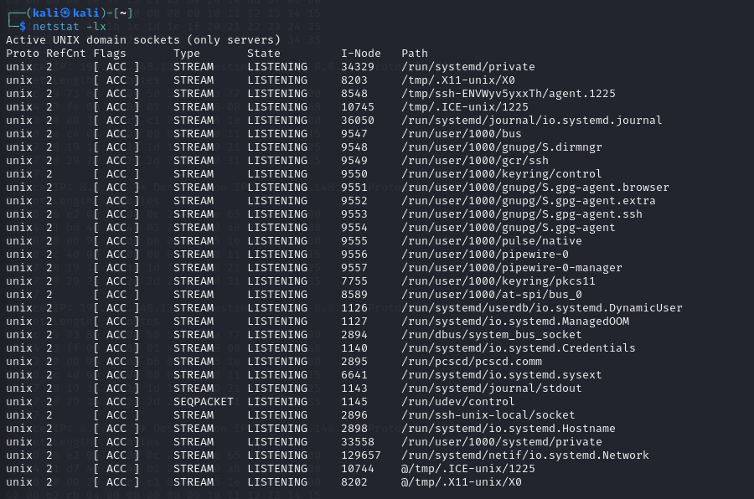

9. Display Statistics by Protocol

Display statistics for all ports regardless of the protocol with:

netstat -s

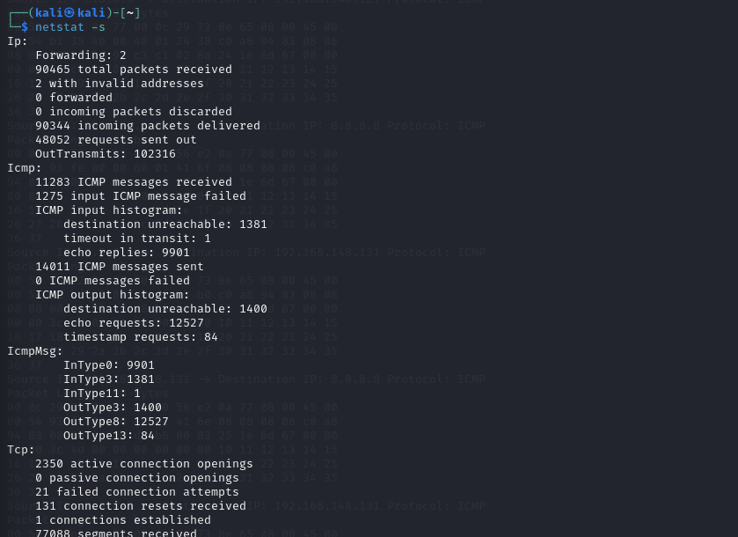

10. List Statistics for TCP Ports

List statistics for TCP ports only with:

netstat -st

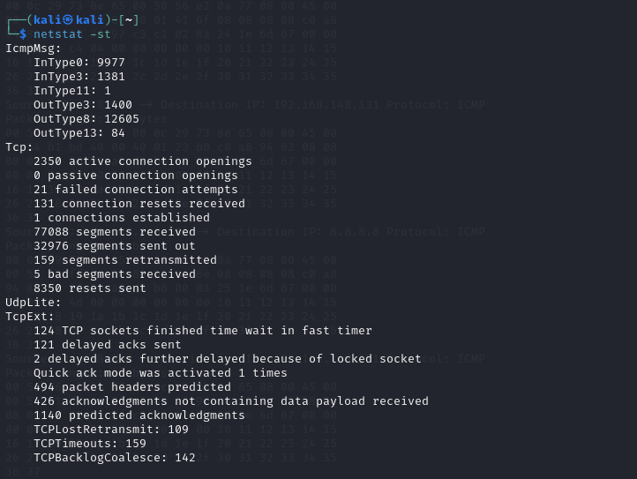

11.List Statistics for UDP Ports

To list statistics for UDP ports only, use:

netstat -su

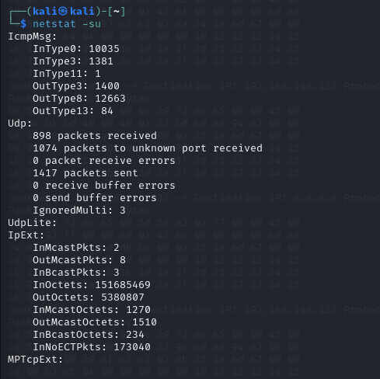

12. List Network Interface Transactions

To see transactions of MTU, receiving and transferring packets in the kernel interface table, use:

netstat -i

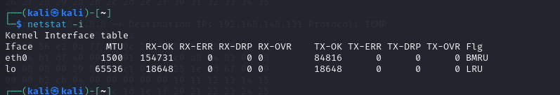

13. Display Extended Kernel Interface Table

Add the option -e to netstat -i to extend the details of the kernel interface table:

netstat -ie

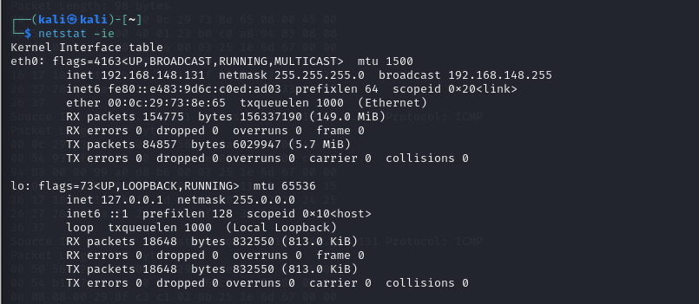

14. Display Masqueraded Connections

For displaying masqueraded connections, use:

netstat -M

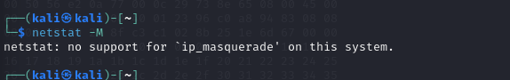

15. Display PID

Display the PID/Program name related to a specific connection by adding the -p option to netstat. For example, to view the TCP connections with the PID/Program name listed, use:

netstat -tp

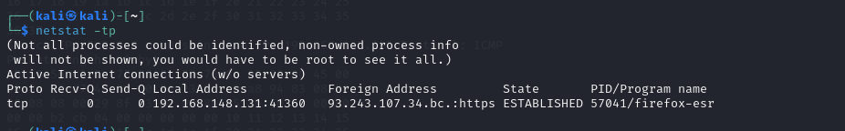

16. Find Listening Programs

Find all listening programs with:

netstat -lp

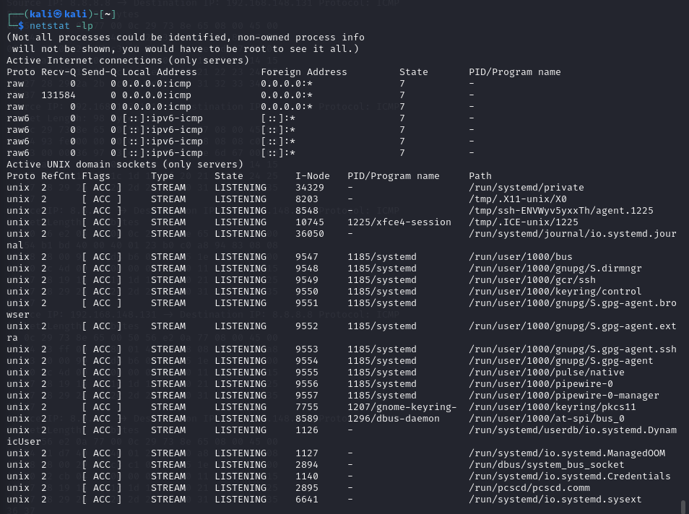

17. Display Kernel IP Routing Table

Display the kernel IP routing table with:

netstat -r

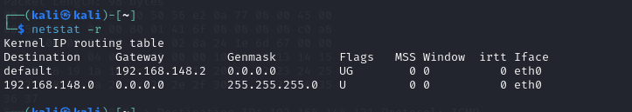

18. Display IPv4 and IPv6 Group Membership

Display group membership for IPv6/IPv4 with:

netstat -g

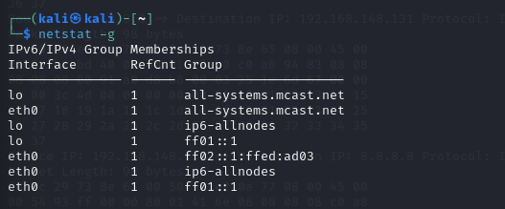

19. Print netstat Info Continuously

Add the -c option to the netstat command to print information every second:

netstat -c

For example, to print the kernel interface table continuously, run:

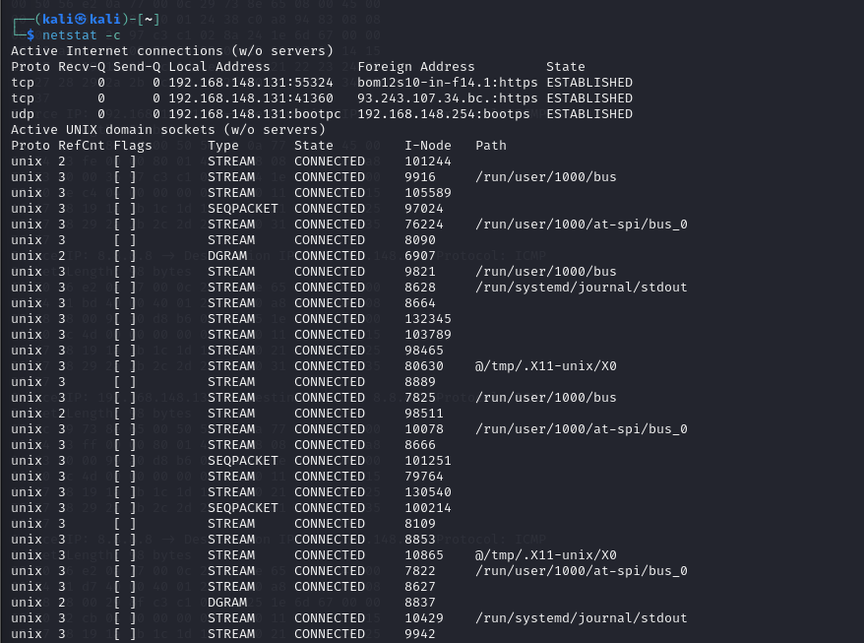

netstat -ic

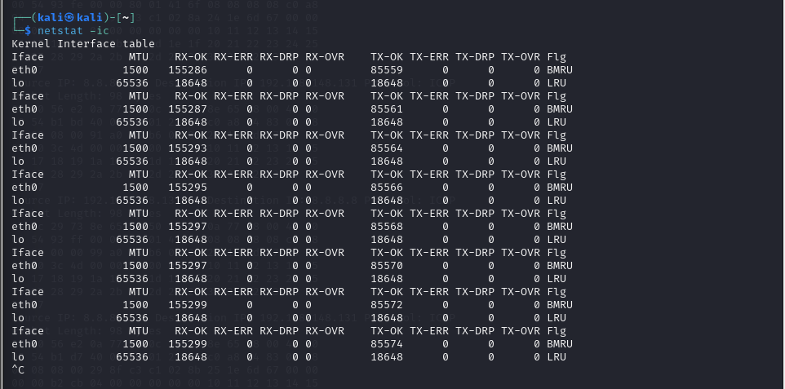

20. Find Unconfigured Address Families

List addresses without support on the system with:

netstat –verbose

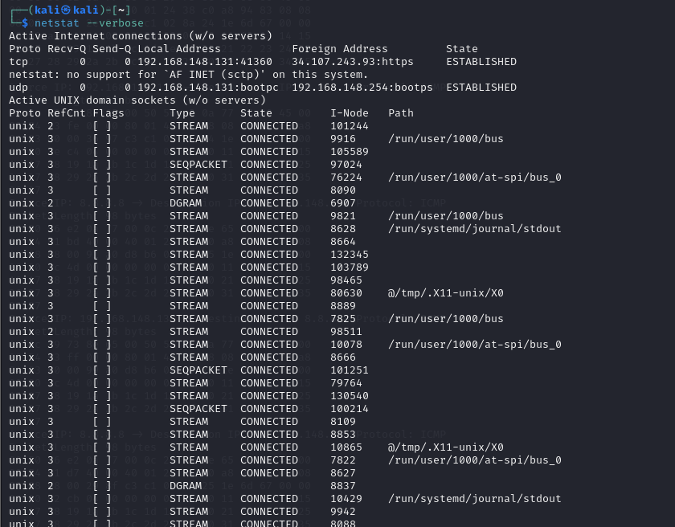

21.Display Numerical Addresses, Host Addresses, Port Numbers, and User IDs

By default, addresses, port numbers, and user IDs are resolved into human-readable names when possible. Knowing the unresolved port number is important for tasks such as SSH port forwarding.

Display Numerical Addresses

Show numerical addresses with:

netstat -n

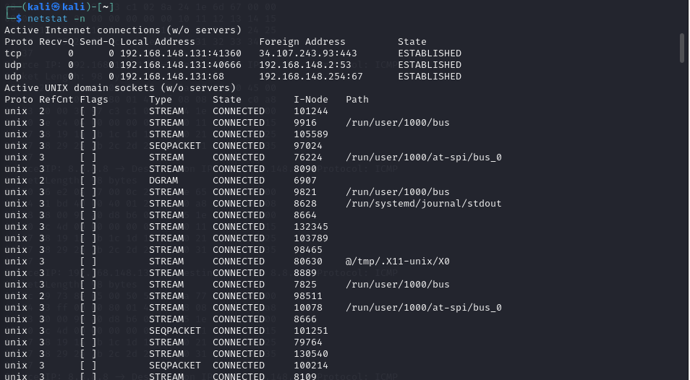

Display Numerical Host Addresses

To show only host addresses as numerical, run:

netstat --numeric-hosts

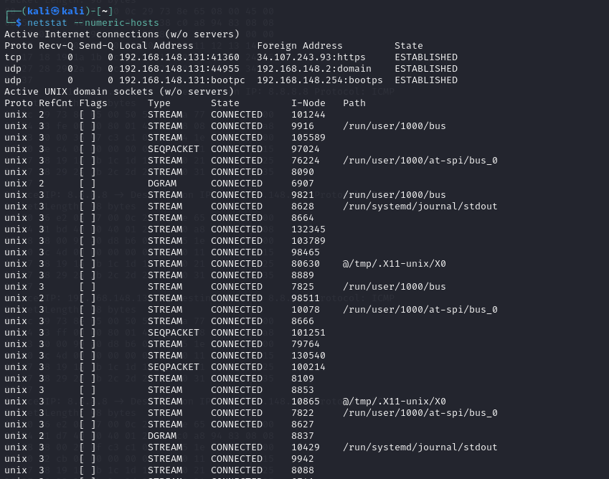

Display Numerical Port Numbers

Show only ports as numerical with:

netstat --numeric-ports

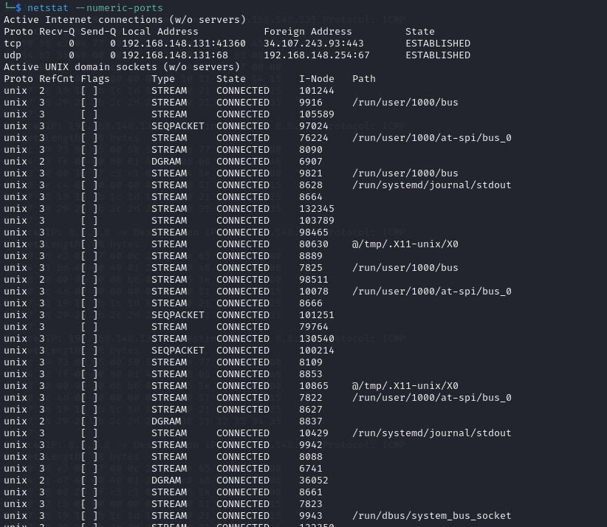

Display Numerical User Ids

To display numerical user IDs, use:

netstat --numeric-users

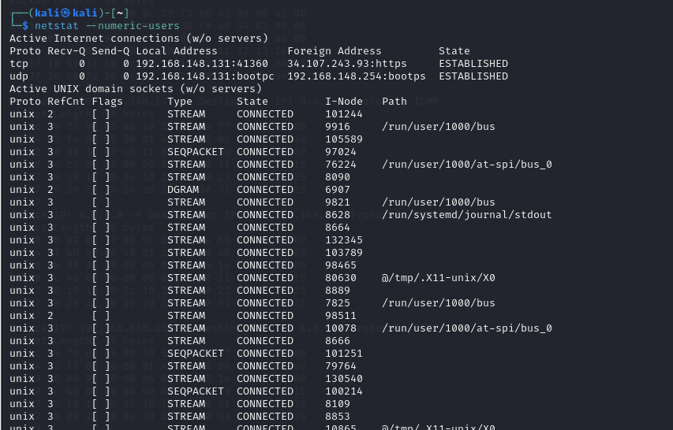

22.Find a Process That Is Using a Particular Port

Make use of the grep command to filter the data from netstat. To find a process that is using a particular port number, run:

netstat -an | grep ':[port number]'

For example:

netstat -an | grep ':80'

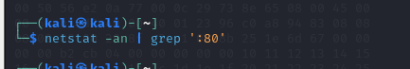

Terminal output of the command netstat -an | grep

23.List All netstat Commands

There are many netstat options available. Access the list of all the available commands and a short description using:

netstat -h

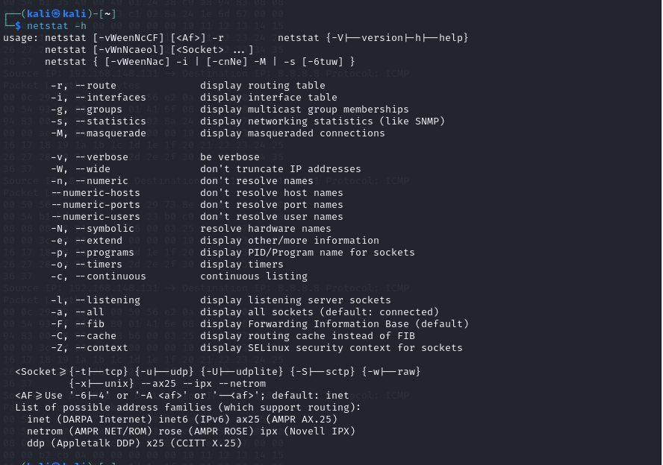

Terminal output of the command netstat -h